FORMAT FOR PNT Lab Internship – Final Report Submission

PNT Lab Internship – Final Report
Powered by: Geo-Intel Lab, IITTNiF
Project Title: HANUMA (Hazard Analysis & Navigation Unit for Mine Assistance)

Intern Name: B Venkat Gopi Nayak
M Bindu Madhavi

Under the Guidance of
Name of Faculty Mentor: Dr Shaik Fayaz Ahamed
Designation: Associate Professor
Institution: Siddhartha Academy of Higher Education

Supported by
Geospatial Intelligence and Applications Laboratory,
IIT Tirupati Navavishkar I-Hub Foundation

Introduction
The internship conducted under the PNT Lab at IIT Tirupati Navavishkaar I-Hub Foundation involved the design and development of an experimental rover system named HANUMA – Hazard Analysis & Navigation Unit for Mine Assistance. The project was centred on creating a compact mobile platform capable of gathering environmental measurements, streaming real-time video, and transmitting GPS-based position information to a remote interface.
- The work covered several stages, including defining the system architecture, integrating multiple sensors using ESP32, configuring Raspberry Pi 5 for continuous video streaming, establishing GPS-based tracking, designing the rover chassis, and assembling all modules into a functional prototype.
- This project relates directly to geospatial and positioning technologies, as it makes use of satellite-based location data, sensor telemetry, and remote monitoring techniques to support navigation and hazard assessment in restricted or mine-like environments. By combining embedded systems, IoT communication, and live geolocation, the system demonstrates how PNT technologies can enhance safety and improve situational awareness in real-world applications.
2. Aim and Objectives
To design and develop a compact rover system capable of performing hazard monitoring, real-time GPS-based navigation, environmental sensing, and remote video streaming to support mine-assistance and safety operations.
Objectives
- To establish a stable system architecture using a dual-processor setup with ESP32 and Raspberry Pi 5.
- To integrate environmental sensors for gas, temperature, vibration, and tilt measurements.
- To configure GPS modules for accurate real-time coordinate tracking.
- To implement wireless communication for transmitting sensor, GPS, and video data to a cloud interface.
- To develop a functional rover chassis with proper motor control and structural stability.
- To enable live video streaming through Raspberry Pi 5 with a secure access interface.
- To design a simplified PCB layout to reduce wiring complexity and improve reliability.
- To combine all hardware and software components into a complete working prototype suitable for testing in controlled environments.

Methodology
The HANUMA rover system was developed through a sequence of hardware integration, software configuration, data acquisition, and prototype testing steps.
- Data was gathered using the following modules:
- Gas Sensors (NO₂, CO₂) – hazardous gas detection
- Temperature Sensor – ambient monitoring
- Vibration & Tilt Sensors – stability and terrain feedback
- Rotary Encoder – wheel rotation and movement estimation
- GPS Module (NEO-6M) – real-time coordinates
- Webcam – live visual feed
Tools Used: ESP32 (sensor acquisition), Raspberry Pi 5 (video processing), ThingSpeak API (cloud upload).

- Software and Technologies
- Arduino IDE – ESP32 programming
- TinyGPS++ – NMEA GPS parsing
- Python (Pi OS) – webcam and streaming control
- fswebcam / v4l2 – camera testing
- Flask / UV4L – live streaming
- RealVNC & PuTTY – Pi remote configuration
- Things peak & Custom Webpage – cloud dashboard and secure access
- Analytical / Modelling Methods
- Sensor calibration and noise filtering
- GPS data cleaning and coordinate extraction
- Streaming latency optimization
- Power management evaluation for stable operation
- Experimental setup or workflow
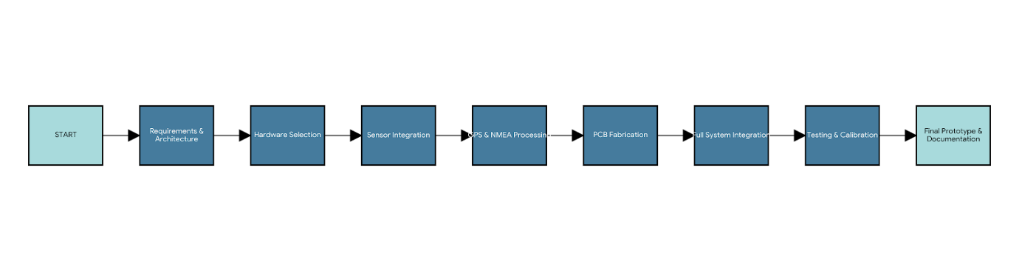4. Results and Discussion
The output link contains the final visuals of the HANUMA rover after completing system integration and testing. The uploaded images show the finished prototype, including PCB wiring, motor setup, sensor placement, and overall chassis design. These outputs confirm that all modules—ESP32, Raspberry Pi 5, GPS, sensors, and webcam—operated together as a functional system. The rover demonstrated stable movement, live video streaming, and accurate data transmission during testing, validating the design and build quality.
Output link:
https://github.com/Gopinayak02/HANUMA_Weekly_Report/tree/main/week8

5. Conclusion
The HANUMA rover project resulted in a fully functional system capable of sensing environmental conditions, streaming live video, and providing GPS-based location tracking. All integrated components operated reliably during testing, confirming the effectiveness of the design and implementation.
The internship strengthened technical skills in embedded systems, sensor integration, GPS processing, IoT communication, PCB development, and real-time data handling. It also improved practical understanding of geospatial and positioning technologies through hands-on project work.

6. Learning Experience
- Technical Skills:
- Gained hands-on experience in embedded systems, sensor integration, GPS handling, and real-time data processing.
- Worked with Python streaming, PCB wiring, cloud dashboards, and tools like Arduino IDE and Raspberry Pi OS.
- Soft Skills:

- Improved teamwork, communication, and problem-solving abilities.
- Enhanced planning and project coordination skills.
- Exposure:
  - Learned from mentor guidance and practical engineering workflows at the PNT Lab.
  - Understood real-world applications of geospatial, navigation, and IoT technologies.

7. Gratitude and Acknowledgement
We would like to express heartfelt gratitude to Geo-Intel Lab, IIT Tirupati Navavishkar I-Hub Foundation (IITTNiF) for providing this opportunity through the PNT Lab hosted at our institution.
The mentorship, resources, and collaborative ecosystem created by Geo-Intel Lab, IITTNiF, greatly contributed to strengthening understanding of geospatial and positioning technologies.
Sincere appreciation is extended to the faculty mentor, peers, and the IITTNiF team for their continuous guidance, support, and encouragement throughout the internship.

8. References
Technical & System References
- Espressif Systems. (n.d.). ESP32 technical reference manual. https://www.espressif.com/
- Raspberry Pi Foundation. (n.d.). Raspberry Pi 5 documentation. https://www.raspberrypi.com/
- u-blox. (n.d.). NEO-6M GPS module datasheet. https://www.u-blox.com/
- Hart, M. (n.d.). TinyGPS++ library documentation. https://github.com/mikalhart/TinyGPSPlus
- Pallets Projects. (n.d.). Flask web framework documentation. https://flask.palletsprojects.com/
- MathWorks. (n.d.). ThingSpeak API documentation. https://thingspeak.com/
- STMicroelectronics. (n.d.). L298N motor driver datasheet.

Coal & Mining Safety References
- Directorate General of Mines Safety (DGMS). (n.d.). Guidelines for safety in coal mines. Government of India.
- Singh, R., & Sharma, T. (2018). Hazard identification and risk analysis in coal mining. Journal of Mining Science, 54(2), 312–320.
- Wu, Q., & Zhu, C. (2019). Monitoring hazardous gases in underground coal mines using sensor-based systems. International Journal of Mining Science and Technology, 29(4), 567–574.
- Zhang, D., et al. (2020). Application of robotics and IoT technologies in underground coal mine safety. IEEE Access, 8, 117650–117661.

Annexures
Intern’s Signature:
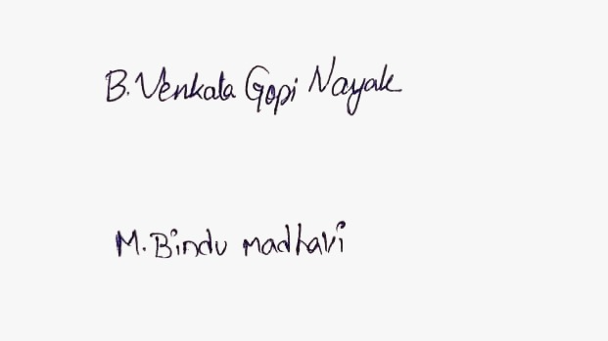
Faculty Mentor’s Signature:

Institution Seal (if applicable)

